**Supplementary Materials: Statistical learning of frequent distractor locations in visual search involves regional signal suppression in early visual cortex**

Bei Zhang1*, Ralph Weidner2, Fredrik Allenmark1, Sabine Bertleff3, Gereon R. Fink2,4,

Zhuanghua Shi1, Hermann J. Müller1

1 General and Experimental Psychology, Ludwig-Maximilians-Universität München, 80802, München, Germany

2 Cognitive Neuroscience, Institute of Neuroscience and Medicine (INM-3), Research Centre Jülich, 52428, Jülich, Germany

3 Traffic Psychology and Acceptance, Institute for Automotive Engineering (ika), RWTH Aachen University, 52074, Aachen, Germany.

4 Department of Neurology, University Hospital Cologne, Cologne University, 50937, Cologne, Germany

* Corresponding author

Correspondence concerning this article should be addressed to **Bei Zhang**, General and Experimental Psychology, Ludwig-Maximilians-Universität München, 80802, Munich, Germany. Email: beizhangbrain@gmail.com. Phone: +49 89 2180 16587. Fax: +49 89 2180 5211.

# 

# 

# **Section S1: Potential ‘repetition suppression’**

For both the behavioural and the fMRI data, we performed an additional analysis by excluding all trials *n* on which a distractor 1) was present and 2) occurred at the same location as a distractor on the preceding trial *n–1* (i.e., distractor-location repetition trials). This was done to rule out confounding effects especially of the early visual-cortex fMRI (VOI) results by repetition suppression (Kristjánsson et al. 2007; Larson and Smith 2012), i.e., reduced neural activation generated by the second of two consecutive (distractor) stimuli. Given that distractors appeared with a probability of 20% at any one of the four locations in the frequent (as compared to 5% in the rare) region, distractor-location repetitions – were more likely in the frequent region, potentially giving rise to an (overall) increased repetition-suppression effect. As detailed below, the results of this reanalysis basically replicated those reported in the main document. Hence, we conclude that the reduced neural response in the early visual cortex to distractors in the frequent versus the rare region is attributable to statistically learnt distractor-location suppression, rather than repetition suppression.

## **Behavioural results**

Behaviourally, as depicted in Figure S1, the error rate was overall higher in the same- vs. the different-dimension condition (16.35% vs. 13.74%); and, compared to the distractor-absent baseline (12.69%), more errors were made on trials in which a distractor was present in the rare region (16.54%) or the frequent region (15.92%). A repeated-measures ANOVA with the factors Distractor (absent, present in the frequent region, present in the rare region) and Distractor Type (different-dimension, same-dimension) revealed all effects to be significant: Distractor, *F*(2, 62) = 15.19, *p* < .001, .048; Distractor Type, *F*(1, 31) = 5.72, *p* = .023, .029; interaction, *F*(2, 62) = 9.05, *p* < .001, .026.

An analogous ANOVA of the mean RTs also revealed all effects to be significant: Distractor, *F*(2, 62) =111.09, *p* < .001, .084; Distractor Type, *F*(1, 31) = 64.14, *p* < .001, .135; interaction, *F*(2, 62) = 59.4, *p* < .001, .056. As depicted in Figure S1b, the distractor interference effect was 8 ms with different-dimension distractors, *t*(31) = 3.24, *p* = .003, but ten times as high (83 ms) with same-dimension distractors, *t*(31) = 13.4, *p* < .001; this differential interference effect was significant, *t*(31) = -11.9, *p* < .001. Importantly, the distractor-location effect (i.e., the reduced interference for distractors in the frequent vs. the rare region) was significant with same-dimension distractors (22-ms benefit, *t*(31) = 3.51, *p* = .001), but not with different-dimension distractors (6-ms benefit, *t*(31) = 1.32, *p* = .20); and, as expected from multiple previous studies, the benefits deriving from distractor-location learning were significantly larger in the same- vs. the different-dimension distractor condition (paired one tailed t test, *t*(31) = -1.76, *p* = .04). Moreover, RTs were slower to targets appearing in the frequent vs. the rare region with different- (10-ms slowing, *t*(31) = 2.52, *p* = .017) as well as same-dimension distractors (18-ms slowing, *t*(31) = 4.40, p < .001); the numerical (1:2 ratio) difference between the two distractor types was non-significant, *t*(31) = -1.18, *p* = .248.

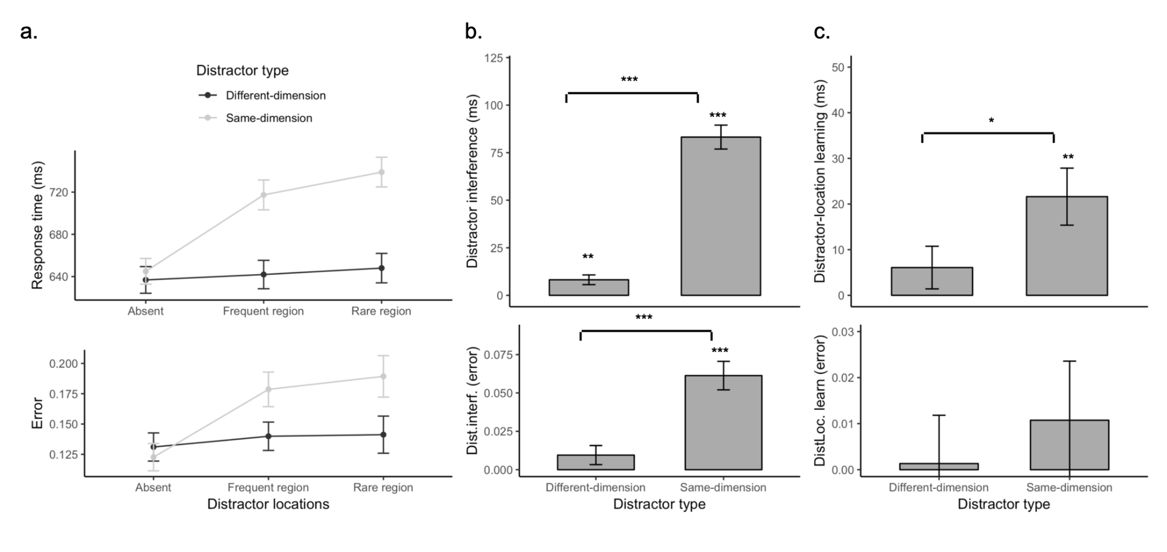

**Figure S1*.*** *Response times (RTs; upper panels) and error rates (lower panels) for the two distractor types on distractor-location non-repeat trials. (a) Averaged RTs and error rates in the three distractor conditions, separately for the different- and same-dimension distractor types. (b) Distractor-interference effect, calculated as the difference between distractor-present and -absent trials, separately for the different- and same-dimension distractor types. (c) Distractor-location learning effect, calculated as the difference between trials with a distractor presented in the rare vs. frequent region, separately for the different- and same-dimension distractor types. Error bars depict 95% confidence intervals. * denotes p < .05, ** p < .01, *** p < .001.*

## **VOI results**

The extracted beta values (percent signal change) were submitted to a two-way repeated-measures ANOVA with the within-subject factors Distractor Region (frequent region, rare region) and Distractor Type (different-, same-dimension distractor). Consistent with the analysis before removing distractor-location repetition trials in the main document, the results also revealed a significant main effect of Distractor Region, *F*(1, 25) = 4.98, *p* = .03, while the main effect of Distractor Type, *F*(1, 25) = 1.11, *p* = .30, and the Distractor Type × Distractor Region interaction, *F*(1, 25) = 0.14, *p* = .71, were non-significant (see Figure S2). Further paired t-tests comparing the beta values between the frequent and rare distractor regions, separately for the two distractor types, revealed the difference to be significant for the same-dimension condition (rare vs. frequent region: -0.001 vs. -0.332, *t*(25) = 2.04, *p* = .05), but not for the different-dimension condition (0.412 vs. -0.006, *t*(25) = 1.67, *p* = .11). Thus, even after removing distractor-location repetition trials (that could give rise to a differential ‘repetition- suppression’ effect between the two regions), the VOI results also indicated a general reduction of early visual-cortex activation evoked by distractors occurring in the frequent vs. the rare region, and this effect was statistically robust only with same-dimension distractors, but not with different-dimension distractors.

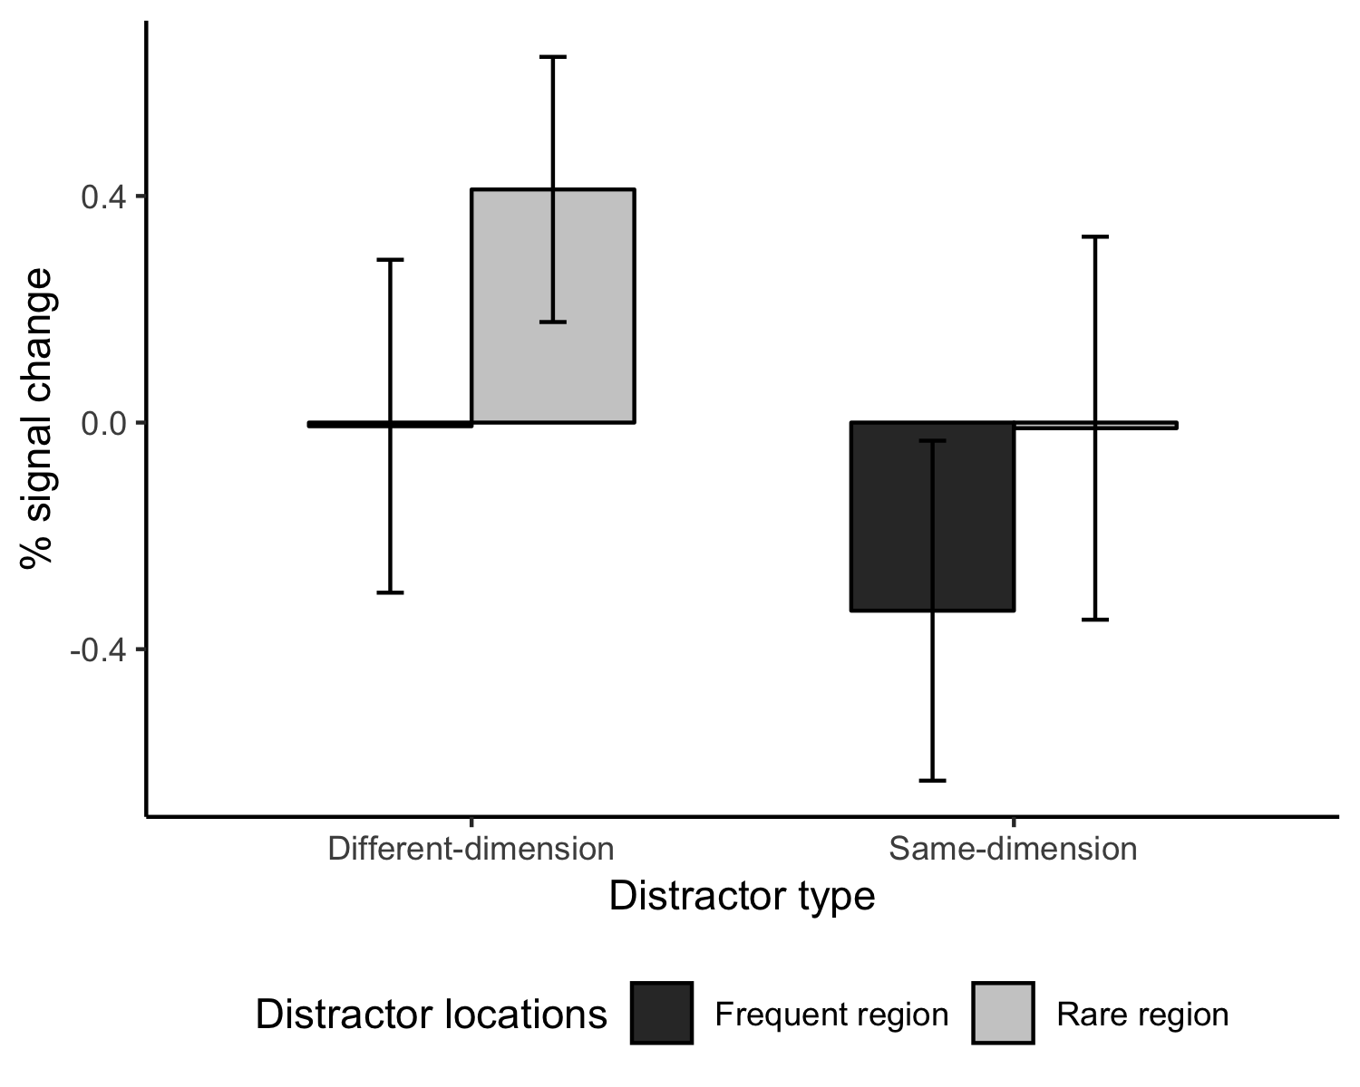

**Figure S2***. Mean percent signal change (beta values) representing early visual-cortex activation by singleton distractors appearing in the frequent vs. the rare distractor region, separately for the different- and same-dimension distractor types. Error bars depict 95% confidence intervals.*

As depicted in Figure S3, we also re-analysed the relationships between the beta values and the RT interference caused by distractors occurring in the frequent and, respectively, the rare region, for each of the two distractor-type conditions. Replication the findings in the main document, the beta values were predictive of the magnitude of RT interference magnitude only in the same-dimension condition (frequent region: *r* = .52, *p* = .006, *BF* = 9.61; rare region: *r* = .38, *p* = .05, *BF* = 2.00), but not the different-dimension condition (frequent region: *r* = -.23, *p* = .27, *BF* = 0.708; rare region: *r* = -.25, *p* = .22, *BF* = 0.799).

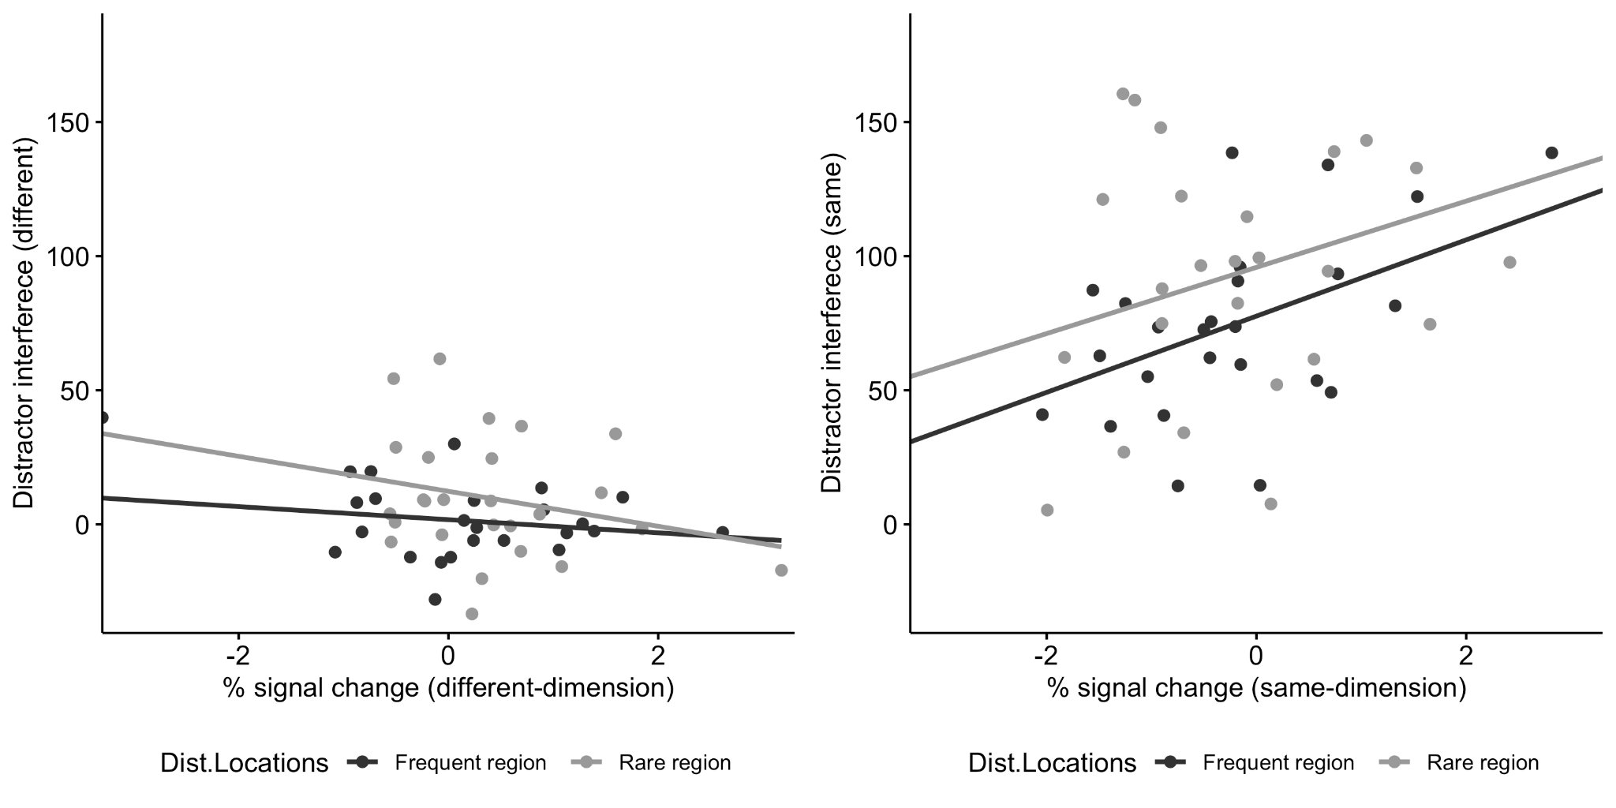

**Figure S3**. *Correlation between behavioural distractor interference effect (RTs) in the frequent region and the rare region with the respective percent signal changes for distractors in the frequent and rare region, separately for the different- (left panel) and the same-dimension distractor types (right panel).*

Of note, on trials on which the distractor location repeated within the frequent region, early visual activation (in the respective VOIs) was actually somewhat increased, rather than reduced, compared to non-repeat trials (repeat vs. non-repeat trials: 0.03 vs. -0.15), for both types of distractor (main effect of distractor location repetition vs. non-repetition: F(1,25) = 9.93, p = .004, = .005). [For the rare region, this analysis could not be performed, as there were too few trials with a distractor-location repetition in this region.] This again argues against the beta-value gradient between the frequent and rare distractor regions being attributable to a repetition-suppression effect.

# **Section S2: VOI results for the retinotopic cortex areas V1–V4**

To take a more detailed look at visual activation in retinotopic visual cortex, we re-defined the four position-localizer VOIs separately for each early visual cortex area V1, V2, V3, and V4, based on the early visual-cortex atlases from Wang et al.’s (2015) probabilistic visual-topography maps, adopting a 25% probability threshold combined across the left and right hemispheres and the dorsal and ventral areas. Specifically, based on each of V1 to V4 atlases, we identified voxels that were visually responsive to the four position localizers. Results indicated that all four position localizers activated V1, V2, and V3, but only two localizers activated V4 (uncorrected, p < .001, with a minimum cluster size of 20 contiguous voxels). Thus, we defined the four position-localizer VOIs within areas V1, V2, and V3, separately (see Figure S4). We then extracted percent signal changes for each distractor regressor/location (again excluding distractor-location repetition trials, as in the analyses presented in Section S1) within the corresponding VOIs of each early-visual cortex area (V1–V3).

As depicted in Figure S5 (upper panels), by visual inspection, the beta values were overall lower for distractors appearing in the frequent versus the rare region in V1, V2, and V3. However, likely owing to the small volume size of the VOIs, a repeated-measures ANOVA with the factors Distractor Region (frequent region, rare region) and Distractor Type (different-, same-dimension distractor) failed to reveal significant main effects of Distractor Region for V1 (*F*(1, 25) = 1.51, *p* = .23), V2 (*F*(1, 25) = 3.02, *p* = .09), and V3 (*F*(1, 25) = 0.007, *p* = .93).

Further, we analysed the correlations between the beta values in V1–V3 and the RT interference caused by distractors occurring in the frequent and, respectively, the rare region, for each of the two distractor-type conditions. As can be seen from Figure S5 (bottom panels) the results for V1–V3 closely resemble the global, sphere-based VOI results in the main document, with significant (or near-significant) correlations in the same-dimension distractor condition, but not the different-dimension condition: *V1*, same-dimension distractors (frequent region: r = .27, p = .17; rare region: r = .35, p = .08), different-dimension distractors (frequent region: r = -.12, p = .54; rare region: r = -.03, p = .87); *V2*, same-dimension distractors (frequent region: r = .47, p = .02; rare region: r = .37, p = .06), different-dimension distractors (frequent region: r = -.25, p = .20; rare region: r = -.06, p = .78); and V3, same-dimension distractors (frequent region: r = .44, p = .02; rare region: r = .32, p = .10), different-dimension distractors (frequent region: r = .005, p = .98; rare region: r = -.27, p = .18). Taken together, the observed pattern – of reduced visual activation for distractors appearing in the frequent versus the rare region with both types of distractor, and significant correlations between behavioural interference and distractor-invoked visual activation only for the same- (but not different-) dimension distractors – is consistent across the early retinotopic visual areas. The fact that neural activation was reduced for the frequent distractor region in all early visual areas would be consistent with suggestions that the attentional-priority map is situated in the pulvinar of the thalamus (e.g., Bundesen et al. 2005; Kastner and Pinsk 2004) in its inferior and lateral parts, the pulvinar thalamus contains clearly organized retinotopic maps that are reciprocally connected with cortical areas V1, V2, V4, and MT, while receiving (‘saliency’) signals from SC and (indirectly, via SC) from LIP and FEF.

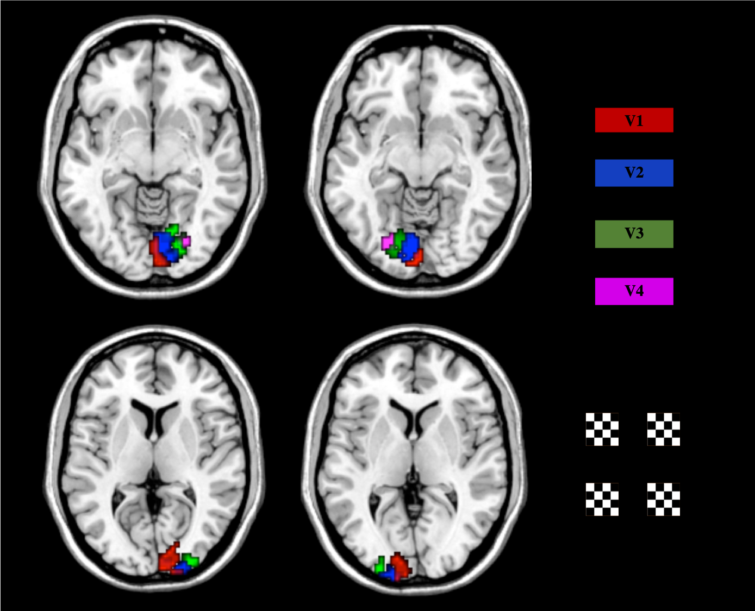

**Figure S4** *Early visual-cortex areas (V1–V4) visually responsive to the four position localizers with uncorrected p < .001 and a minimum cluster size of 20 contiguous voxels.*

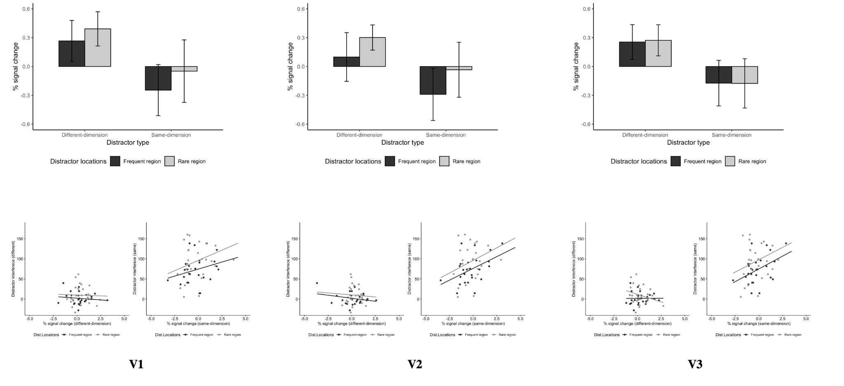

**Figure S5** *Mean percent signal change (upper panels) by the distractor appearing in the frequent vs. the rare distractor region, and correlation (bottom panels) of the behavioural distractor interference effect (RTs) with the respective percent signal change for distractors in the frequent and, respectively, rare regions, separately for two distractor types and the three early visual-cortex areas V1–V3. Error bars depict 95% confidence intervals.*

# 

# **Section S3: Order factor**

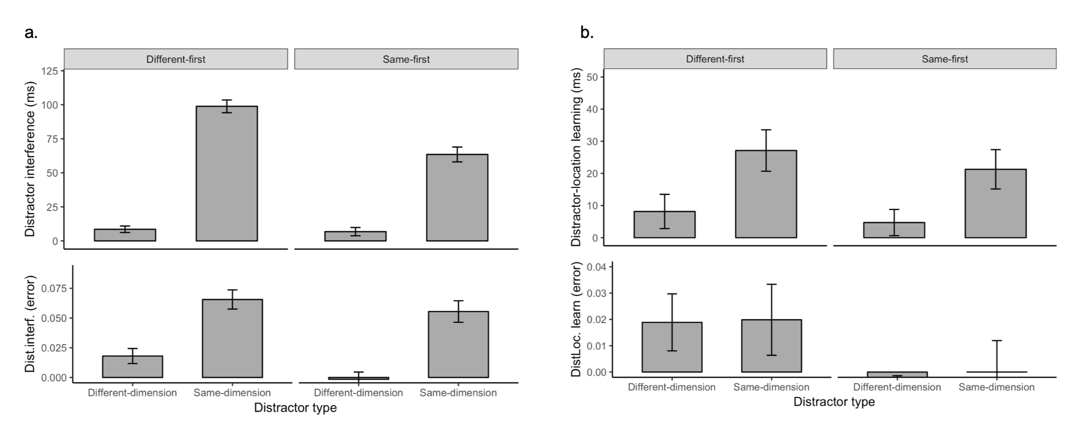

**Figure S6.**  *(a) Behavioural distractor-interference and (b) distractor-location learning effects (response-time and error-rate measures in the upper and lower panels, respectively) for the two distractor-type conditions (different-, same-dimension), separately for participants who performed the different-dimension condition first and those who performed the same-dimension condition first. Error bars depict 95% confidence intervals.*

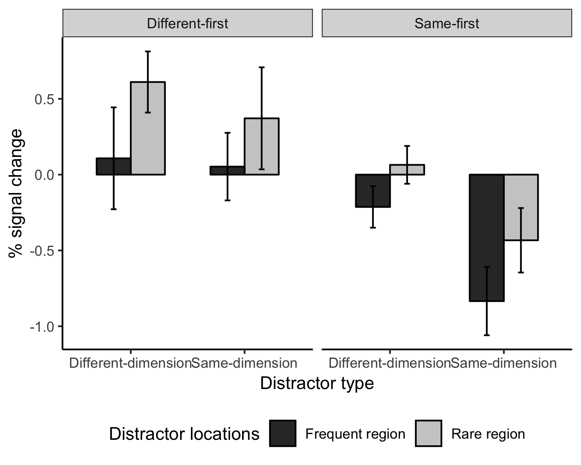

**Figure S7***. Mean percent signal change in the early visual-cortex VOIs evoked by different- and, respectively, same-dimension distractors appearing in the frequent vs. the rare distractor region, separately for participants who performed the different-dimension condition first and those who performed the same-dimension condition first. Error bars depict 95% confidence intervals.*

**Section S4: Model of distractor suppression**

In the discussion section of the main manuscript, we suggest a possible explanation of why we observed an almost equal difference in distractor-generated neural activation (in early visual-cortex areas) between the frequent and rare regions in the different- compared to the same-dimension distractor condition, even though behaviourally both overall distractor interference and the distractor-location learning (or probability-cueing) effect were much reduced in the different dimension session. We proposed that this pattern of effects may result from the interplay of two mechanisms in the different-dimension condition: spatially tuned suppression in the early visual cortex followed by spatially uniform down-weighting of signals from the task-irrelevant color dimension. As a proof-of-principle for this explanation, we performed a simple model simulation, implementing this ‘dimension-weighting’ hypothesis [(Müller et al. 1995)](https://paperpile.com/c/ug2HWI/ypDp).

We assume that there are separate neural populations for the color and orientation dimensions, and within each dimension a separate sub-population corresponding to each of the possible target and distractor locations in the search display. In order to explain the observed correlations between behavioral distractor interference and distractor-generated BOLD activity, we modelled 26 “simulated participants”, where we assume that the response to the distractor differed between participants but, for simplicity, the responses to targets and non-targets are the same. Specifically, the target and the non-targets respectively contribute the amounts of activation 𝛼T and 𝛼NT to the orientation-tuned neural populations associated with the locations at which they occur and make no contribution to the color-tuned populations. The singleton distractor contributes to the orientation-tuned neurons in the same dimension session and to the color-tuned populations in the different dimension session, and that the amount it contributes differed across participants, following a normal distribution with mean 𝜇AS and standard deviation 𝜎AS when the distractor occurs in the rare region and scaled down by a factor 𝛾 (0 < 𝛾 < 1) when the distractor occurs in the frequent region. The populations for the color and orientation dimensions contribute equally to the fMRI signal in early visual areas, and that these are later combined, though with less weight, determined by the parameter *wC*, on the task-irrelevant color dimension compared to the relevant orientation dimension, into a single attentional-priority map. Specifically, we model the early visual fMRI signal as the equally weighted average of the contributions of the singleton distractor to activity in the color and orientation populations (one of which was always zero) plus a normally distributed random contribution with zero mean and standard deviation 𝜎BOLD.

The proportion of trials on which the distractor captures attention, pac, is determined by the relative amount of activation of the distractor location on the priority map compared to the total amount of activation summed over all relevant (potential target or distractor) locations on the priority map. The amount of distractor interference for each participant is then modeled as the product of pac and the average RT cost of attentional capture, 𝛥AC, plus a normally distributed random “noise” with zero mean and standard deviation 𝜎INT, representing individual differences in distractor interference. The average RT cost of attentional capture may differ between participants, based on whether a distractor occurs in the frequent or rare region as well as between same- and different-dimension distractors: 𝛥AC = 𝛥R,S + N(0,𝜎𝛥), where 𝛥R,S could be one of four different parameters, one for each combination of distractor region and session (𝛥FR,SD, 𝛥RR,SD, 𝛥FR,SD, 𝛥RR,DD where FR and RR stand for frequent and rare region and SD and DD stand for the same- and different-dimension distractors).

In total the model we described above has13 parameters (𝛼T, 𝛼NT, 𝜇AS, 𝜎AS, 𝛾, wC, 𝛥AC, 𝛥FR,SD, 𝛥RR,SD, 𝛥FR,SD, 𝛥RR,DD, 𝜎𝛥, 𝜎INT). We chose the parameters so that the predicted distractor interference in the different conditions and the predicted correlation between distractor interference and BOLD response was comparable to our experimental data.

We simulated 26 “participants” and repeated the simulation 1000 times to obtain means and standard deviations for the predicted distractor interference, fMRI response and correlations. The model predicted higher average distractor interference and a larger probability cueing effect for the same- versus the different-dimension distractor condition (interference effect: 88 ± 2 ms vs. 12 ± 2 ms; probability-cueing effect: 22 ± 4 ms vs. 4 ± 4 ms), even though the model assumed there were no systematic (non-random) differences in neural activity between the two (same- and different-dimension) distractor conditions, whether in terms of the average across or the difference between the two regions (average: 19.5 ± 0.7 compared to 18.1 ± 0.7, difference: 5.6 ± 1.4 compared to 5.1 ± 1.4). Additionally, we calculated the correlations between the modelled brain activity and the predicted distractor interference. The predicted correlations were smaller for different- versus same-dimension distractors both for distractors, in both the rare region (0.73 ± 0.07 vs. 0.32 ± 0.17) and the frequent region (0.64 ± 0.10 vs. 0.22 ± 0.10), broadly consistent with our findings.

**References**

Bundesen C, Habekost T, Kyllingsbaek S. 2005. A neural theory of visual attention: bridging cognition and neurophysiology. Psychol Rev. 112:291–328.

Kastner S, Pinsk MA. 2004. Visual attention as a multilevel selection process. Cogn Affect Behav Neurosci. 4:483–500.

Kristjánsson A, Vuilleumier P, Schwartz S, Macaluso E, Driver J. 2007. Neural basis for priming of pop-out during visual search revealed with fMRI. Cereb Cortex. 17:1612–1624.

Larsson J, Smith AT. 2012. fMRI repetition suppression: neuronal adaptation or stimulus expectation? Cereb Cortex. 22:567–576.

Müller HJ, Heller D, Ziegler J. 1995. Visual search for singleton feature targets within and across feature dimensions. Percept Psychophys. 57:1–17.